Published courtesy of [CUESA](http://www.cuesa.org/)

***“It’s the mother. Without good soil, there won’t be a good crop.”***

*Nancy Gammons, Four Sisters Farm*

[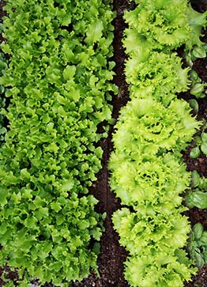](http://www.ecology.com/wp-content/uploads/2012/09/Lettuce-garden-rows.jpg)When you buy a head of lettuce, you may not think about the soil it grew in, but soil is an ever-present concern for farmers. Nancy Gammons of [Four Sisters Farm](http://www.cuesa.org/farm/four-sisters-farm)sums up the significance of soil: “It’s the mother. Without good soil, there won’t be a good crop.” The quality of a farm’s soil makes a big difference in yield, water use, and even the taste of the harvest.

Healthy soil is rich in organic matter, which helps store water, air, and nutrients efficiently. It has the right amount of each nutrient needed for plant growth—not too little, and not too much. Healthy soil teems with life and supports beneficial organisms like earthworms, which aerate and fertilize the soil. A healthy soil produces plants that are more resistant to disease, and it can even yield better tasting, nutrient-rich food.

Caring for the soil is good for the land and the crop, but it can also have an even farther-reaching impact. Sustainable soil management can help mitigate global warming by removing carbon dioxide from the atmosphere and [storing it in the soil as carbon](http://en.wikipedia.org/wiki/Carbon_sequestration).

**As Many Ways as There Are Farmers**

While each farm has its own unique soil, and every farmer has a different approach to soil care, perhaps the most important distinction is between conventional and organic soil management methods. Conventional farmers may use chemical fertilizers to deliver nutrients to their crops and synthetic pesticides to remove pathogens from the soil, substances that are prohibited on certified organic farms. These conventional practices can provide a quick fix, but they can also have long-lasting, damaging effects on the soil, such as reduced fertility, increased erosion, and elimination of beneficial soil organisms. Gammons explains, “If it’s going to poison a bug, it’s going to poison everything. Poison is poison.”

Whereas a conventional farmer may think about feeding the plant the nutrients it needs, organic and sustainable farmers think about feeding the soil. They support the overall health of the soil by adding compost, rotating crops, planting cover crops, and, in some cases, integrating animals into the farm.

[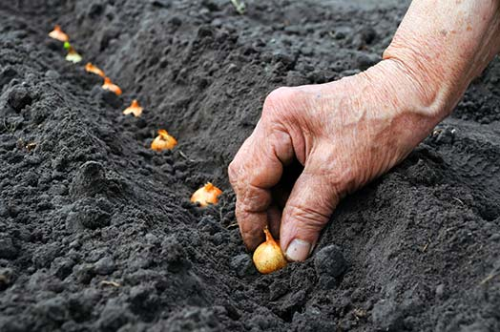](http://www.ecology.com/wp-content/uploads/2012/09/Planting-seeds-row.jpg)

**Sustainable Farmers Grow Soil**

The way farmers treat their soil reflects their farming philosophy and sense of environmental responsibility. Using organic practices and a whole lot of care and effort, Gammons and her family have grown the topsoil at Four Sisters Farm by a whopping 20 inches in the last 20 years. Joe Schirmer of [Dirty Girl Produce](http://www.cuesa.org/farm/dirty-girl-produce) has a similar goal. He says, “When I leave these fields, I want them to be in better shape than when I got them.”

Carl Rosato of [Woodleaf Farm](http://www.cuesa.org/farm/woodleaf-farm" \t "_blank) practices organic no-till farming. He avoids plowing or turning the soil, thus preventing erosion, preserving soil structure, and allowing fungal webs to develop. According to Rosato, fungal webs pull nutrients from long distances toward crops. Although no-till is not the typical way farming is done, it helps build soil, stores carbon, and requires less work over time. Some no-till farmers rely on herbicides for weed control, but Rosato and others are doing it the organic way. To control pests and diseases while keeping the soil as “alive” as possible, he creates habitat for beneficial insects and uses methods like crop rotation.

He says, “It is the way we need to figure out how to farm, but it is difficult,” especially on bigger farms. It requires a healthy soil to begin with and calls for specialized techniques, so it isn’t for everyone. Rosato, a veteran organic farmer, is up to the task. “It works great. I don’t have insect problems. I don’t use sprays. I’ve got a system that functions.” His yields may not be large, but he gets high-quality, flavorful produce.

**Be a Soil Supporter**

[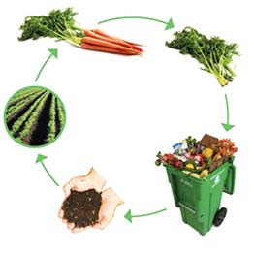](http://www.ecology.com/wp-content/uploads/2012/09/compost-cycle.jpg)Farmers market customers can encourage environmentally friendly soil practices by asking farmers about their techniques and buying from those who take good care of the soil. The organic label means that no synthetic fertilizers or sewage sludge are used on the soil.

At the Ferry Plaza Farmers Market, eaters can reduce waste and return nutrients to the earth by composting their plates, biodegradable cutlery, and food scraps (learn more about our Waste Wise Initiative). Composting at home is easy with San Francisco’s curbside green waste collection through Recology, or if you want to keep that black gold for your garden plants, you can maintain a backyard compost pile or a worm bin. Together, farmers and eaters can build healthy soil, a healthy planet, and healthy communities.

[*CUESA*](http://www.cuesa.org/)*– The Center for Urban Education about Sustainable Agriculture*

[*CUESA*](http://www.cuesa.org/)*thanks recent volunteer intern Grace Dover for contributing to this piece.*